Test Case: tc001_SPX_Dev5_Crear_Requisicion_Spot_Tipo_Cobro_CC
Step 1 - Enter username and password and click to button Enter : Credentials Entered
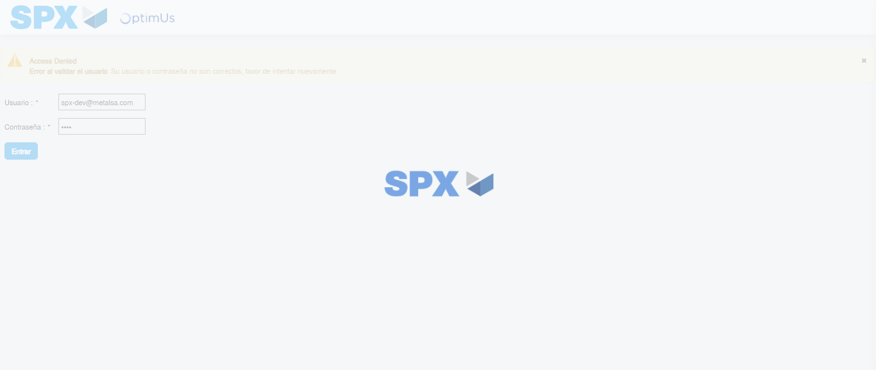Image file-name: QC_Testing-tc001_SPX_Dev5_Crear_Requisicion_Spot_Tipo_Cobro_CC-1782164376380

Step 2 - Select to UEN and Access to Spot Buy Requisitions : UEN Correctly selected and Correct access
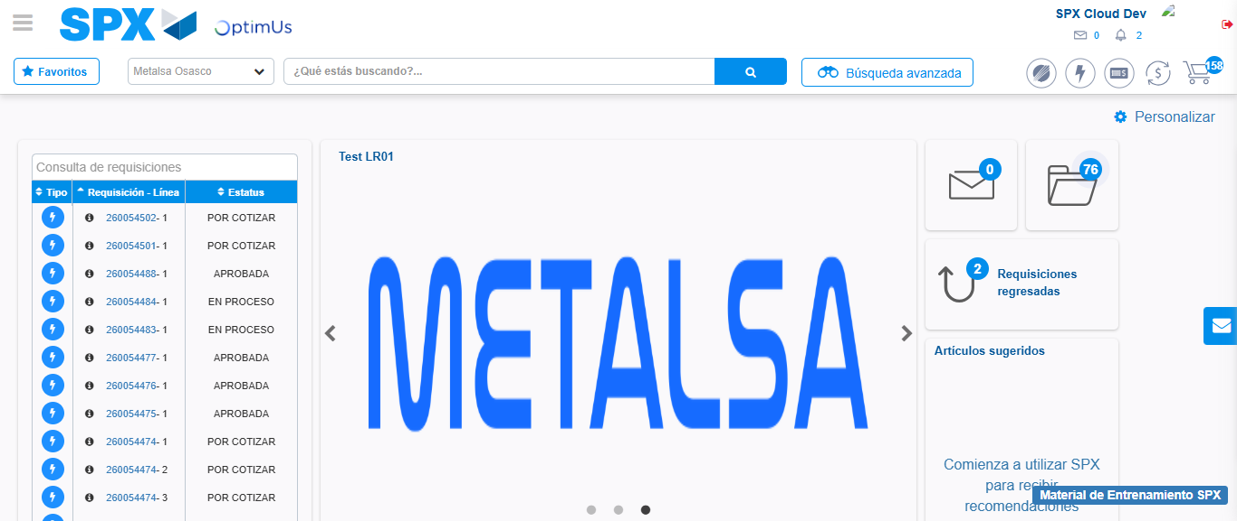Image file-name: QC_Testing-tc001_SPX_Dev5_Crear_Requisicion_Spot_Tipo_Cobro_CC-1782164403698

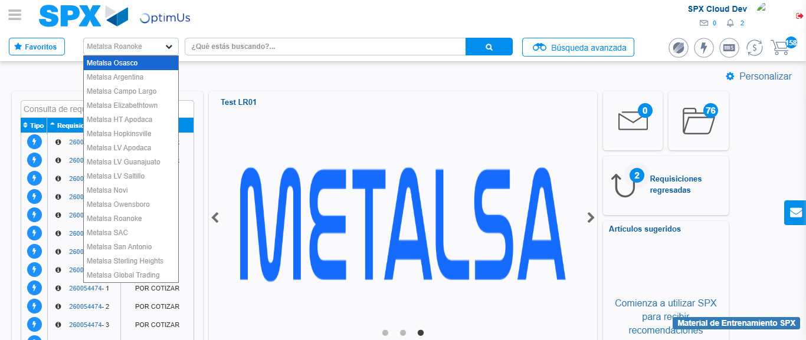Image file-name: QC_Testing-tc001_SPX_Dev5_Crear_Requisicion_Spot_Tipo_Cobro_CC-1782164406245

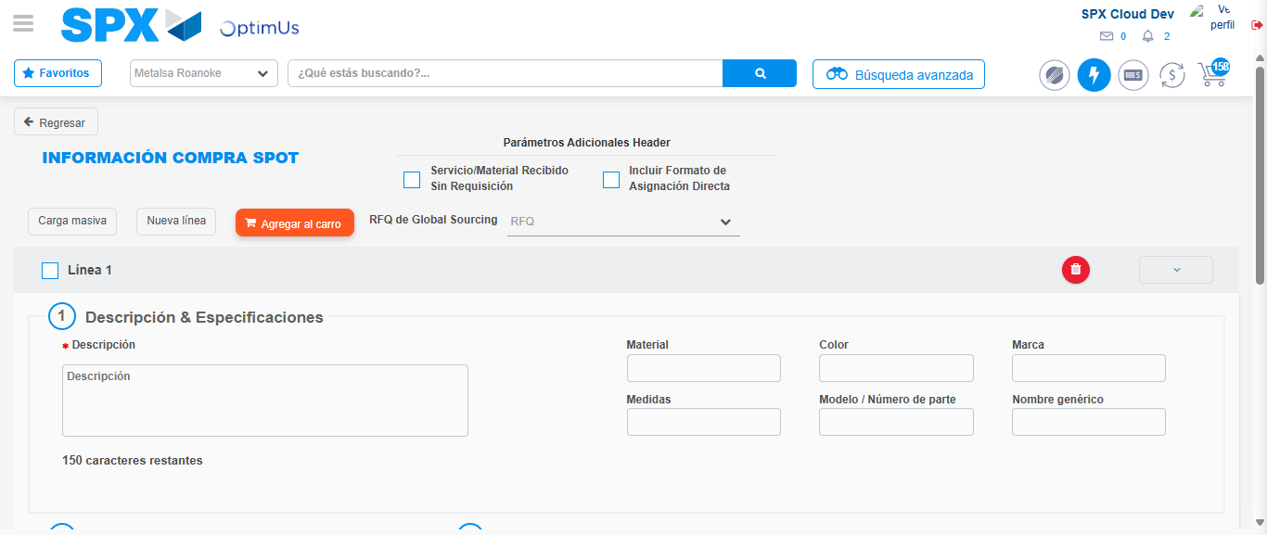Image file-name: QC_Testing-tc001_SPX_Dev5_Crear_Requisicion_Spot_Tipo_Cobro_CC-1782164428591

Step 3 - Data Capture Spot Buy Requisition : Data captured correctly
Image file-name: QC_Testing-tc001_SPX_Dev5_Crear_Requisicion_Spot_Tipo_Cobro_CC-1782164428833

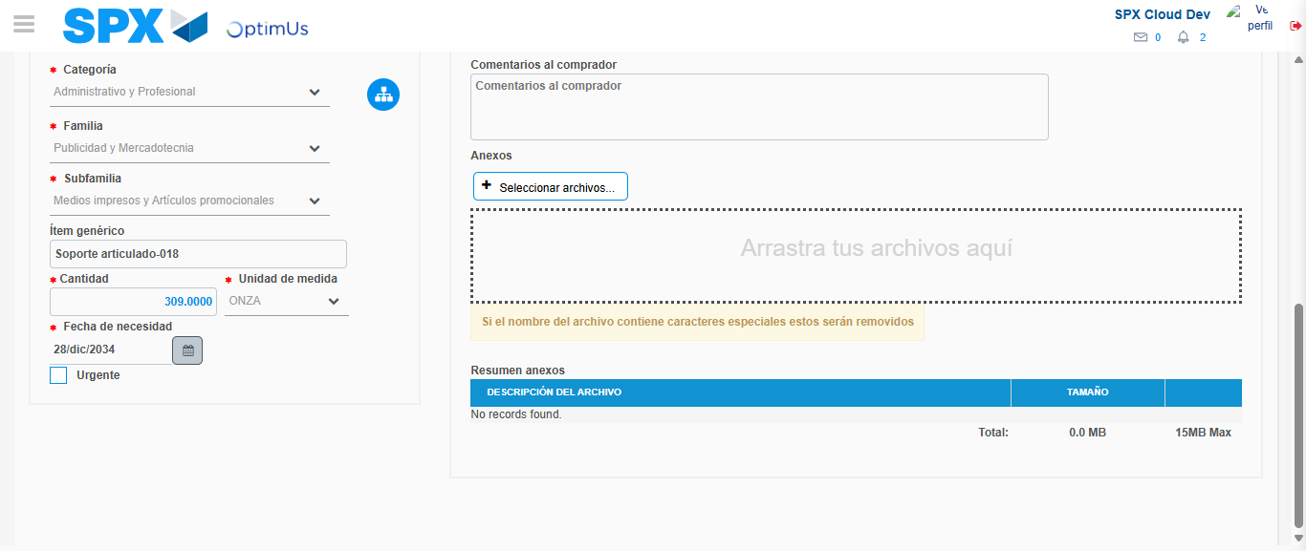Image file-name: QC_Testing-tc001_SPX_Dev5_Crear_Requisicion_Spot_Tipo_Cobro_CC-1782164440698

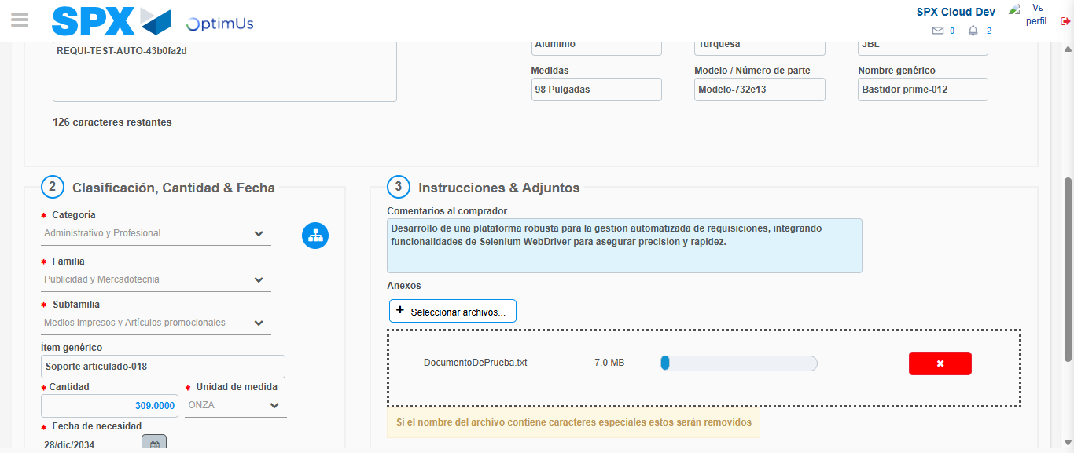Image file-name: QC_Testing-tc001_SPX_Dev5_Crear_Requisicion_Spot_Tipo_Cobro_CC-1782164441458

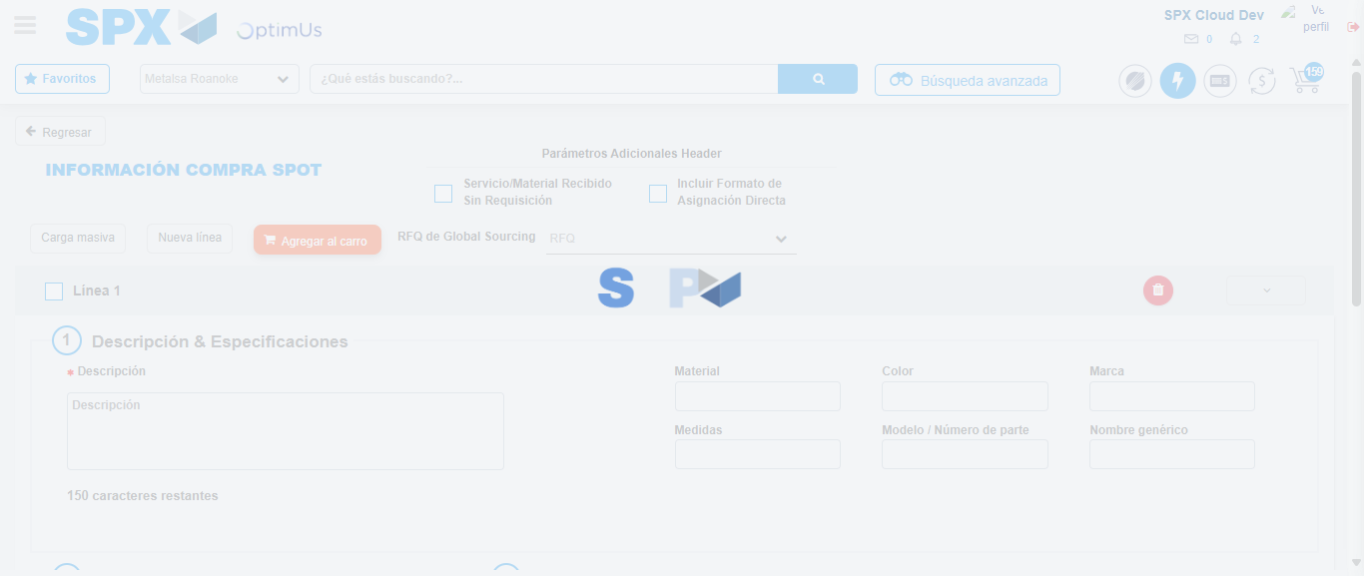Image file-name: QC_Testing-tc001_SPX_Dev5_Crear_Requisicion_Spot_Tipo_Cobro_CC-1782164444930

Step 4 - Select to Requisition : Requisition Correctly selected
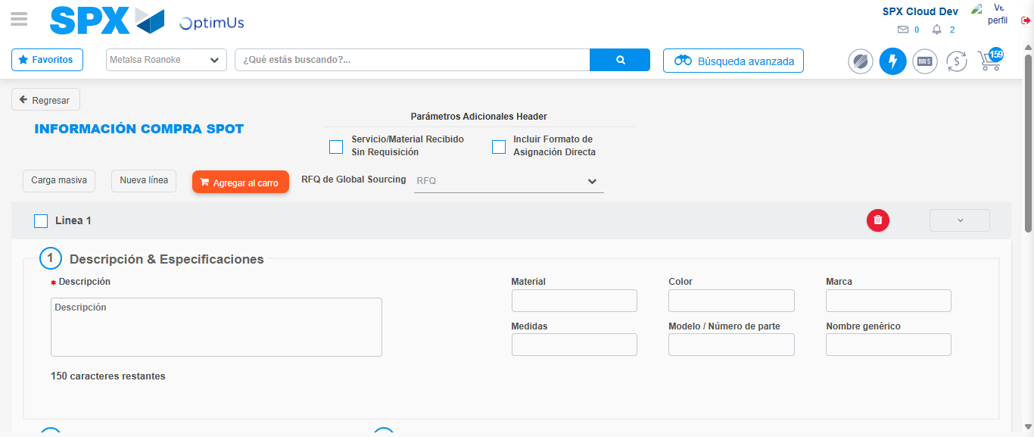Image file-name: QC_Testing-tc001_SPX_Dev5_Crear_Requisicion_Spot_Tipo_Cobro_CC-1782164445146

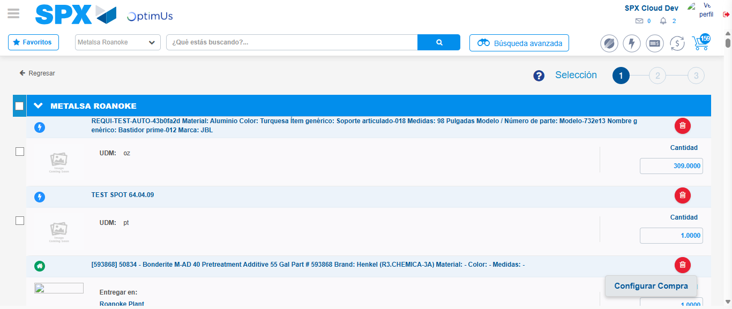Image file-name: QC_Testing-tc001_SPX_Dev5_Crear_Requisicion_Spot_Tipo_Cobro_CC-1782164458580

Image file-name: QC_Testing-tc001_SPX_Dev5_Crear_Requisicion_Spot_Tipo_Cobro_CC-1782164458831

Image file-name: QC_Testing-tc001_SPX_Dev5_Crear_Requisicion_Spot_Tipo_Cobro_CC-1782164459071

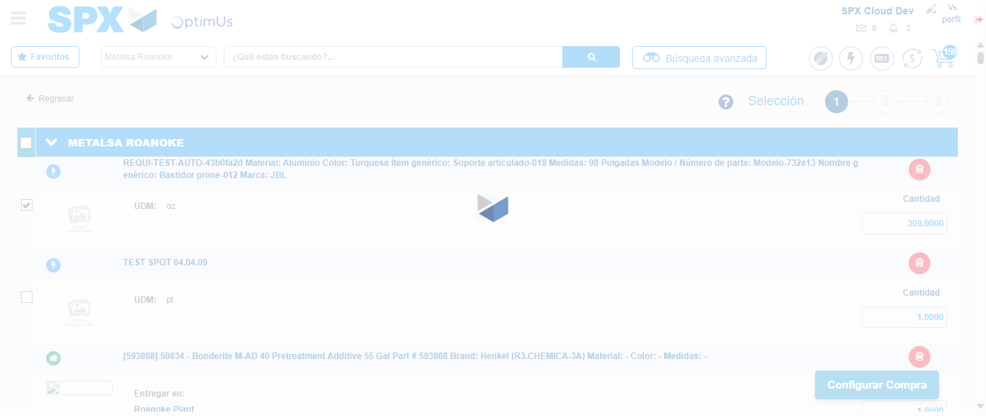Image file-name: QC_Testing-tc001_SPX_Dev5_Crear_Requisicion_Spot_Tipo_Cobro_CC-1782164460981

Step 5 - Select Type Account For Requisition : Type Account Correctly selected
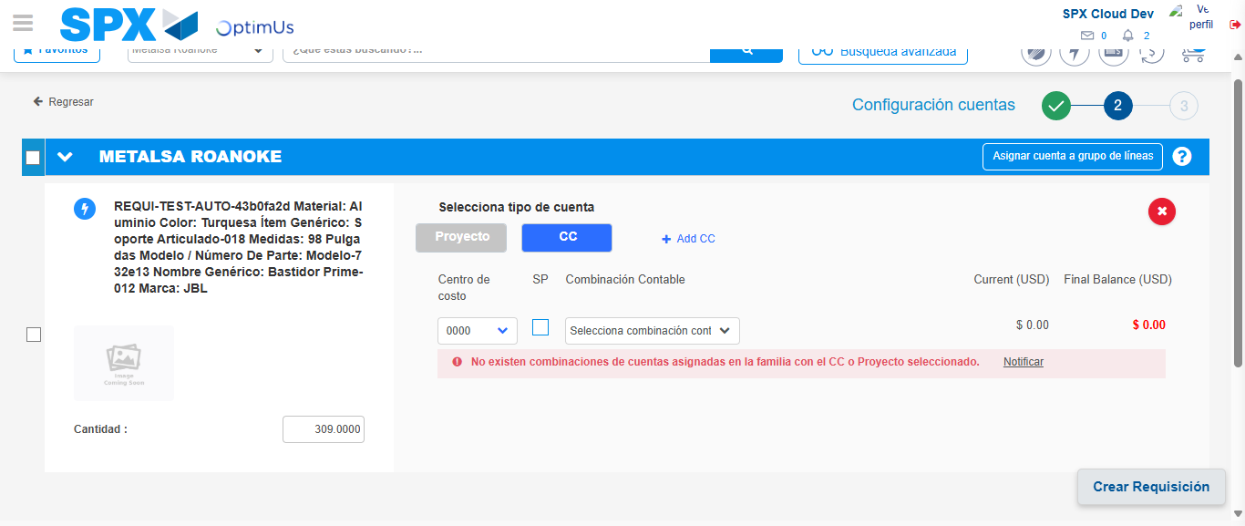Image file-name: QC_Testing-tc001_SPX_Dev5_Crear_Requisicion_Spot_Tipo_Cobro_CC-1782164476111

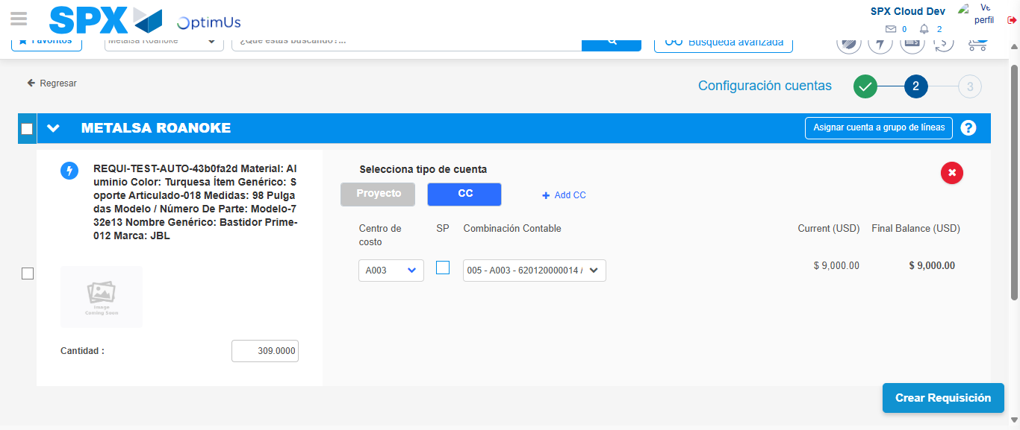Image file-name: QC_Testing-tc001_SPX_Dev5_Crear_Requisicion_Spot_Tipo_Cobro_CC-1782164481393

Image file-name: QC_Testing-tc001_SPX_Dev5_Crear_Requisicion_Spot_Tipo_Cobro_CC-1782164481564

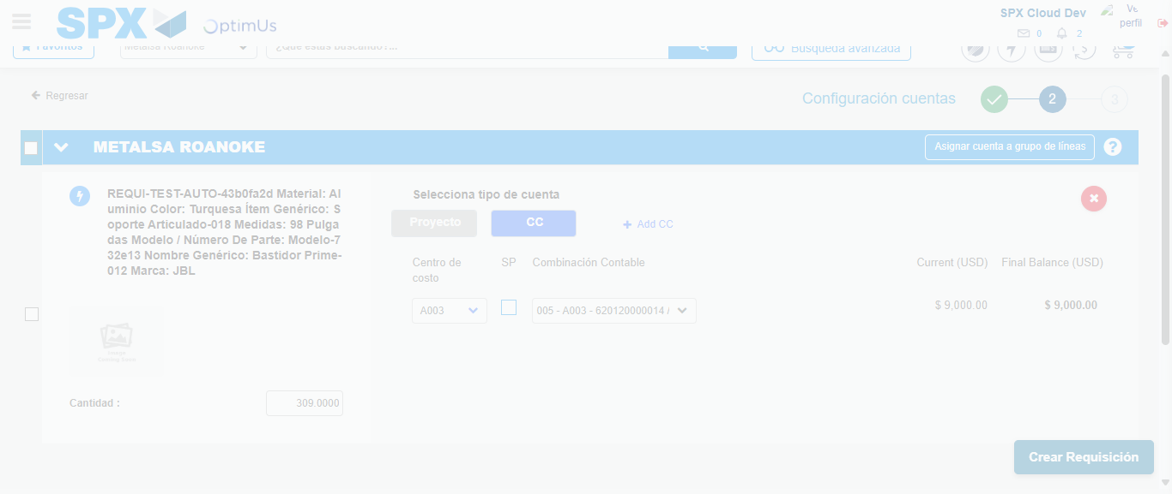Image file-name: QC_Testing-tc001_SPX_Dev5_Crear_Requisicion_Spot_Tipo_Cobro_CC-1782164481966

Step 6 - Accept to Requisition : Requisition Accepted
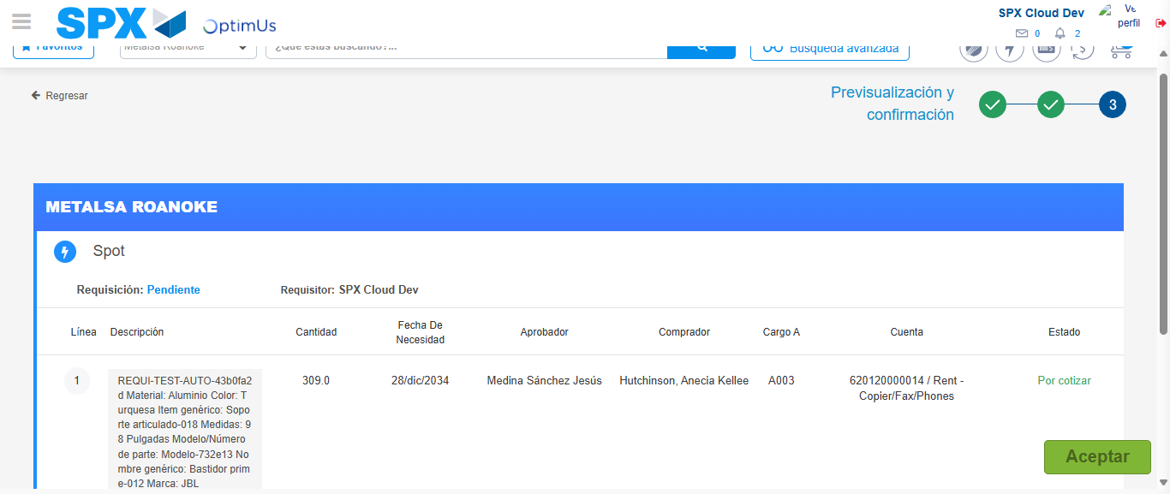Image file-name: QC_Testing-tc001_SPX_Dev5_Crear_Requisicion_Spot_Tipo_Cobro_CC-1782164483265

Image file-name: QC_Testing-tc001_SPX_Dev5_Crear_Requisicion_Spot_Tipo_Cobro_CC-1782164483455

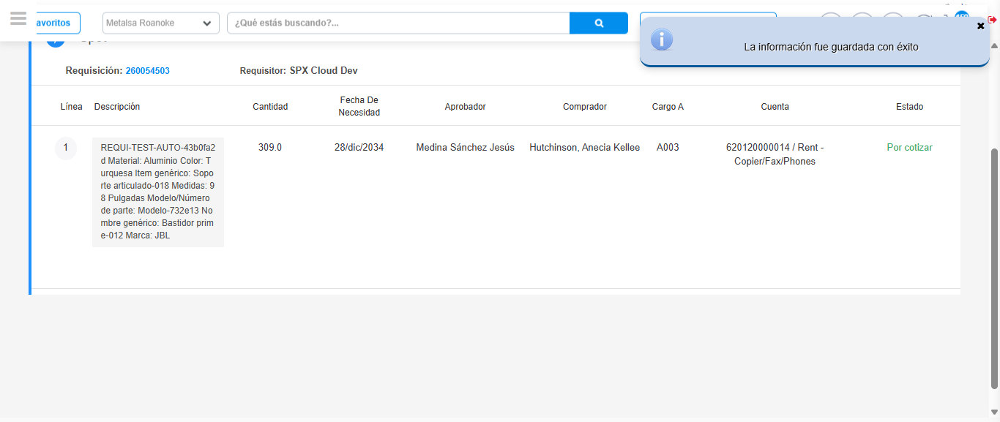Image file-name: QC_Testing-tc001_SPX_Dev5_Crear_Requisicion_Spot_Tipo_Cobro_CC-1782164486351

Step 7 - Return to Main Page SPX : Return to Main Page SPX
Image file-name: QC_Testing-tc001_SPX_Dev5_Crear_Requisicion_Spot_Tipo_Cobro_CC-1782164403698

Image file-name: QC_Testing-tc001_SPX_Dev5_Crear_Requisicion_Spot_Tipo_Cobro_CC-1782164406245

Image file-name: QC_Testing-tc001_SPX_Dev5_Crear_Requisicion_Spot_Tipo_Cobro_CC-1782164428591

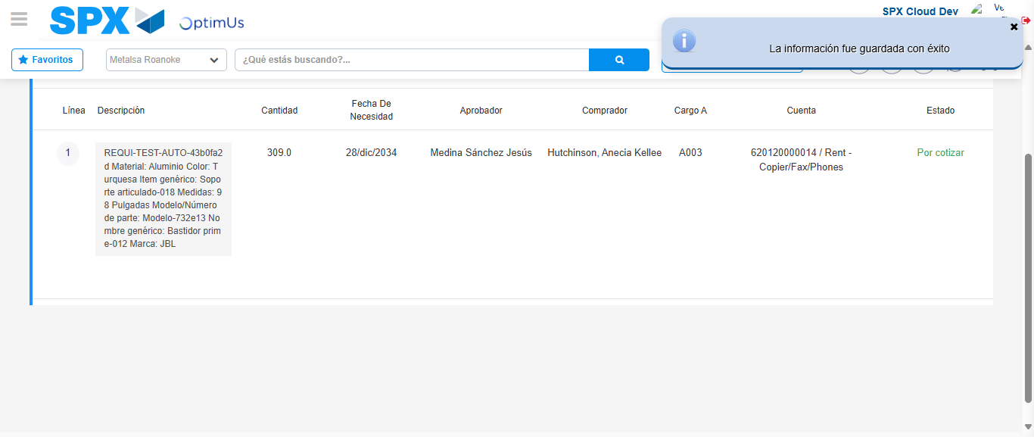Image file-name: QC_Testing-tc001_SPX_Dev5_Crear_Requisicion_Spot_Tipo_Cobro_CC-1782164488521

Image file-name: QC_Testing-tc001_SPX_Dev5_Crear_Requisicion_Spot_Tipo_Cobro_CC-1782164488675

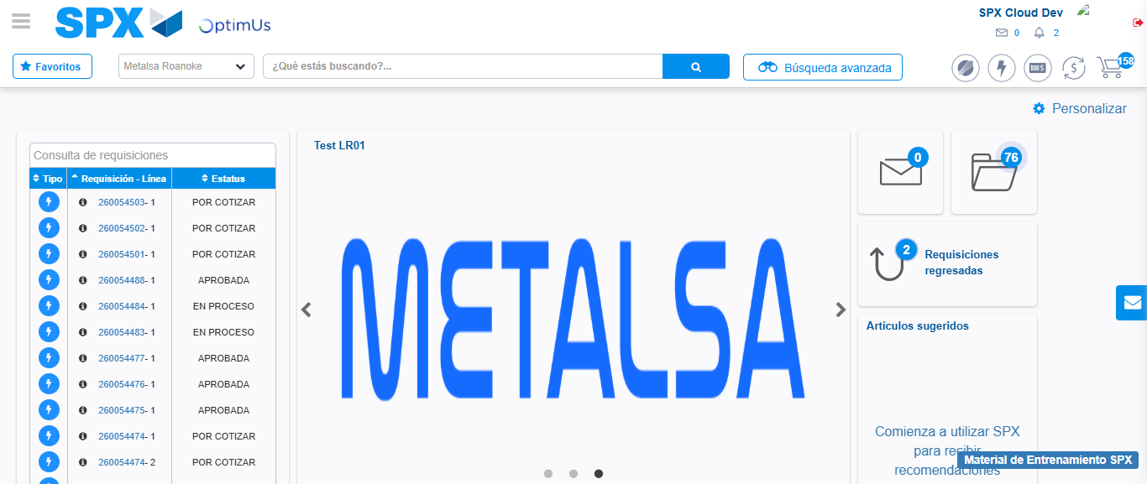Image file-name: QC_Testing-tc001_SPX_Dev5_Crear_Requisicion_Spot_Tipo_Cobro_CC-1782164509730

Step 8 - Log Out : Log Out SPX
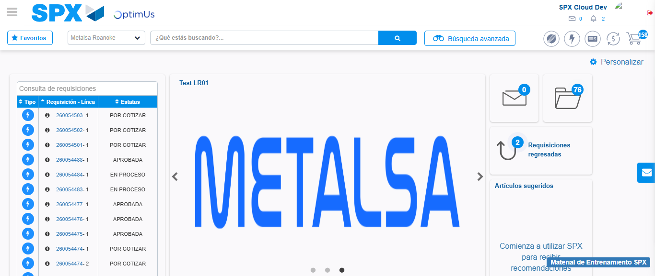Image file-name: QC_Testing-tc001_SPX_Dev5_Crear_Requisicion_Spot_Tipo_Cobro_CC-1782164509997

